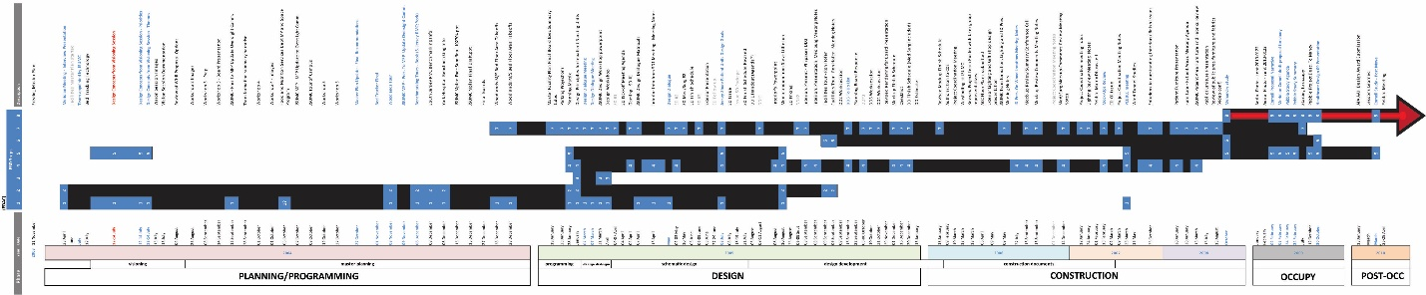

Kelly Egdorf 2009-2010: Jersey Shore University Medical Center – An Evidence‐Based Design Process Case Study
This case study provides an overview and analysis of the EBD process used for the Jersey Shore University Medical Center’s nursing unit from project inception to the capture of preliminary data of the Pebble Study. Organizations elect to join the Pebble Project and commit to evaluating their facility, disseminating their findings, and advance the evidence base for healthcare spaces. Through archival review and focused interviews, the EBD process will be documented. The EBD process utilized by the Jersey Shore team will be analyzed using the universally accepted EDAC process. Focused interviews and surveys will help identify the successes and lessons learned from project inception through the present.
Evidence-based design may offer a roadmap to create the new model of care and the built environment that facilities are seeking. To achieve the best possible outcomes, however, a keen understanding of the process is crucial. This study is intended to create a prototype through which fosters insight into how an EBD process can be implemented into future projects and promote a dialogue about best practices in evidence-based design.

